**TEAM 23**

**DCIT 208 PROJECT 3**

**Contributors: APPIAH DAVID AMOAKO (10841867)**

**KWABENA AMPONG (10843957)**

The System is a Web application that is intended to allow people to create accounts, look through a variety of products which has been grouped into categories. The system allows users to know the cost of the item which they desire to purchase, order them and add them to a virtual cart. Payments are allowed to be made for the items and are delivered to them in a specified period. Users can also post products for potential buyers. The use case diagram below illustrates the system’s overall functionality.

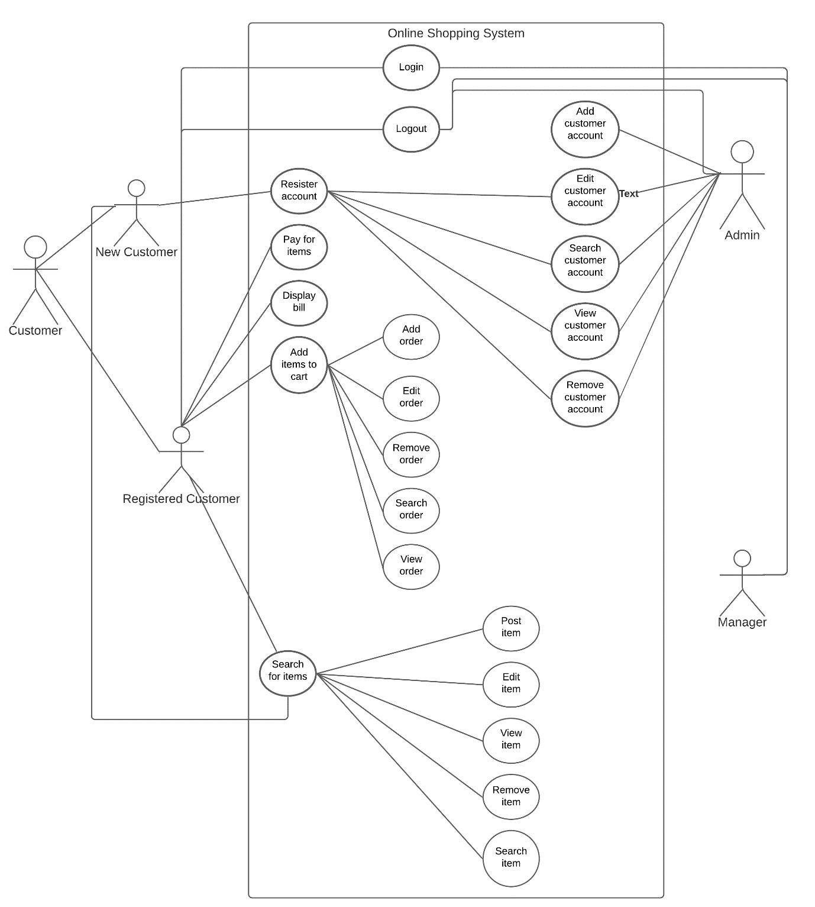

**USER STORIES**

1. The user realizes she wants to view her account so uses the **login** feature to enter into her account.
2. The user desires to see her account so uses the **view customer option** to see her account details.
3. She needs to make some changes to her account so uses the **edit account** feature to make some changes.
4. The user desires to remove her account so selects the **delete customer account** option to delete her account.
5. A new user wants to buy some items so uses the **create account** option to establish an account and gain access to the “Add items to cart” feature.
6. She wants to locate a particular item so and uses the **search** feature to find that particular item.
7. The user, after finding an item uses the **view** option to gain more details about the item.
8. When she finds a product in-store that she wants to buy, she uses the **add item(s)to cart** feature to add the item to her virtual cart.
9. She realizes she wants to order an item so uses the **add order** option to place an order.
10. She wants to see more details of her order so uses the **view order** feature to see more of her order.
11. She wants to make some changes to her order so uses the **edit order** option to edit her order.
12. When she is on a different page and wishes to find locate her order, she uses the **search order** feature to find her order.
13. The user realizes she no longer wants the order so uses the **remove order** option to delete her order.
14. After the user has added some items to the cart, she uses the **display bill** option to determine the exact value of the price of the collective products she added to the cart.
15. The user, wanting to finally purchase the products, uses the **pay for items** feature to purchase them.
16. When the user realizes she wants to sell an item, uses the **post item** option to post her item on the website to attract buyers.
17. The user wants to review the details about her posted item so uses the **view item** option to see them.
18. After the user has posted her product, she uses the **search item** to find her posted item to see how it will look like to potential buyers.
19. She finds herself wanting to make some changes to her posted item so uses the **edit item** to change some details about her product.
20. The user wishes to stop selling her product so uses the **remove item** to delete her posted item from the website.
21. The user wants to leave the website so uses the **logout** feature to end access to the website.

**PRE- AND POST-CONDITIONS**

1. Pre-condition: email address or phone number and its respective password and internet connection.

Post-condition: user gains access to his/her account.

1. Pre-condition: internet connection, an established account and has logged in.

Post-condition: access to the details of an account is given to the user.

1. Pre-condition: internet connection, an established account and has logged in.

Post-condition: access to editable details of the account is given to the user.

1. Pre-condition: internet connection, an established account and has logged in.

Post-condition: user removes her account from the website.

1. Pre-condition: internet connection, valid email address or valid phone number that has been verified, and a suitable password.

Post-condition: user establishes an account and gains access to several other features.

1. Pre-condition: internet connection.

Post-condition: user locates a particular item on the website.

1. Pre-condition: internet connection.

Post-condition: user gains more details about the item.

1. Pre-condition: internet connection, an established account and has logged in.

Post-condition: product is added to the virtual cart.

1. Pre-condition: internet connection, an established account and has logged in.

Post-condition: the item is ordered.

1. Pre-condition: internet connection, an ordered item, and an established account and has logged in.

Post-condition: the details of an order is displayed.

1. Pre-condition: internet connection, an ordered item, and an established account and has logged in.

Post-condition: access to editable details of an order is granted to the user.

1. Pre-condition: internet connection, an ordered item, and an established account and has logged in.

Post-condition: a specific order is located.

1. Pre-condition: internet connection, an ordered item, and an established account and has logged in.

Post-condition: the ordered item is deleted.

1. Pre-condition: internet connection, an ordered item or items in the cart, and an established account and has logged in.

Post-condition: the exact amount to be paid is displayed.

1. Pre-condition: internet connection, an ordered item or items in the cart, and an established account and has logged in.

Post-condition: a payment gateway page is displayed.

1. Pre-condition: internet connection and an established account and has logged in.

Post-condition: the item is posted on the website.

1. Pre-condition: internet connection.

Post-condition: detailed information of a selected product is displayed.

1. Pre-condition: internet connection.

Post-condition: the items related to the keyword is displayed.

1. Pre-condition: internet connection, a posted item, and an established account and has logged in.

Post-condition: access to editable details of the item is granted to the user.

1. Pre-condition: internet connection, a posted item, and an established account and has logged in.

Post-condition: the posted item is deleted from the website.

1. Pre-condition: internet connection and an established account and has logged in.

Post-condition: the user is logged out of his/her account.

**USER STORIES THAT CAN BE BROKEN INTO SMALLER USER STORIES**

**User stories 2, 8, and 18** can be broken down into smaller user stories.

The other user stories cannot be broken down into smaller user stories.

**NON-FUNCTIONAL REQUIREMENTS**

* **Security**: transactions should be secure.
* **Maintainability**: changes should be easily made over time.
* **Performance**: pages should load very fast.
* **Availability**: the website should be always up and running
* **Capacity**: website should be capable of storing an unlimited number of products.
* **Reliability**: the website should be reliable.

**GLOSSARY**

* **Item/ product**: is a piece of goods that can be purchased or posted onto the website.
* **Account**: is an established system connected to a user’s credentials that allows the user access to certain several features.
* **Feature**: This is a characteristic component of the website.
* **Post**: is to display a product on the website for potential buyers to see.
* **Bill**: is the statement of the amount of money owed for goods to be paid by a user.
* **Price**: the amount of money to be paid for a product.
* **Cart(virtual)**: is a feature that works as an interface for customers to buy products.
* **Order**: is the contract between a buyer and the seller when the buyer purchases an item.